**RapidAPI FrontEnd candidate challenge**

**The following questions concerned your thinking process and your orientation to frontend developer at react js.**

**For any questions or problems please contact us.**

**Good luck!**



**Your mission if you choose to accept it:**

1. **Build a page that will contain the following components that will be displayed when you are not logged in:**

* **login fields**
* **Title**
* **Login button**

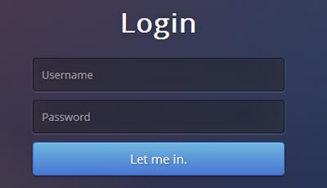

**2. After login the you will be re -directed to an Home page which will contain the following components:**

* **welcome message**
* **logout button**
* **User thumbnail (can be hard coded) which the user can drag and change position on the page**

**3. User will be able to**

**When logged out:**

**can login in.**

**When logged in:**

* + **Can drag the image and drop it in a different location and the application will remember the last location of the image**
* **can logout**

Take into consideration:

1. Data flow architecture.
2. CSS architecture with concern to scale of the application.
3. Saving data - You can work with Local storage but treat it as it was API that you are using to save image location.
4. Work with build system (Bower, npm, gulp)
5. Store your solution on github

Bonus Task:

Use RapidAPI solution for using API’s.